Hi, I need a desktop scraper/parser software(for Win 10) for the site hintwise.com, it should be for continual updating of the database so it's not just a fixed number of pages.

I want to scrape all four sports. The data should be saved as XML files(singular file per game): <https://hintwise.com/>

I need this data: Sport: Soccer Source: Hintwise

Country

League

Date

Time

Home team

Away team

Score prediction

Home/draw/away odds

Over/under 2.5 odds

Both to score odds

Double chance odds

Home win/Away win odds

Final Score

The app has to be able to fetch historic data using older dates: <https://hintwise.com/?date=2018-08-01&show=all>

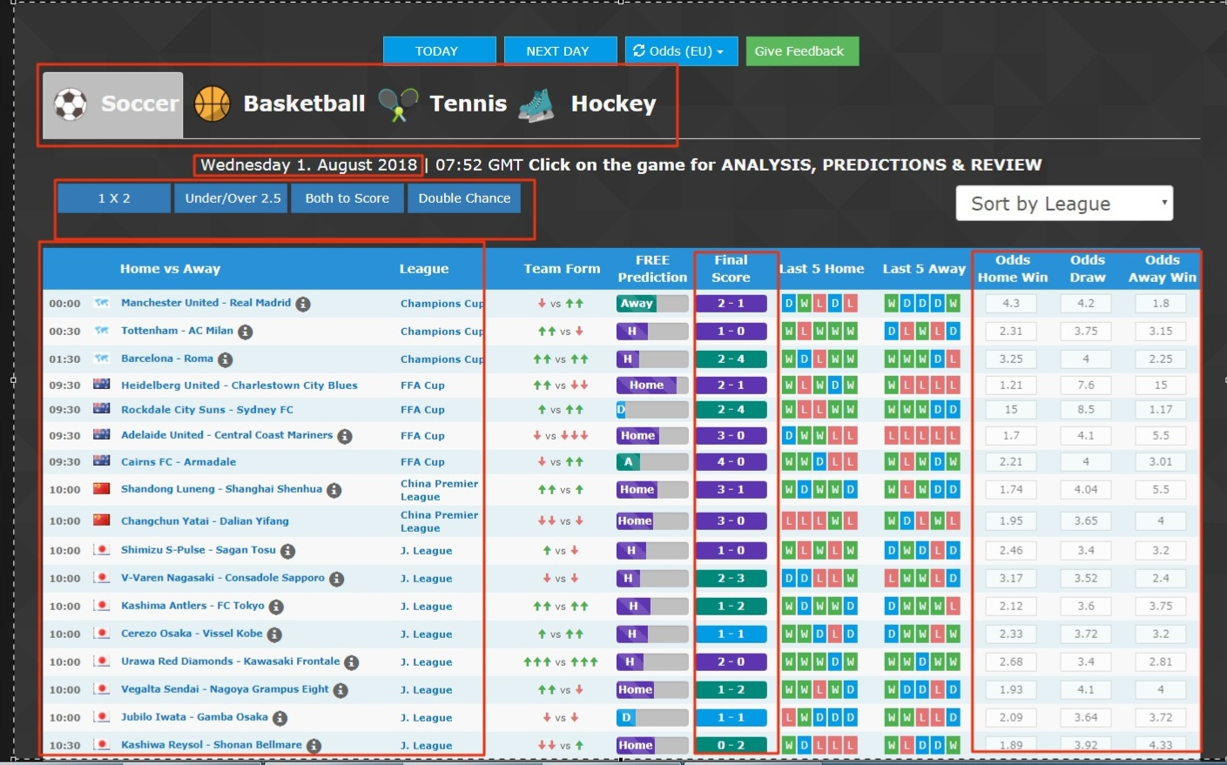

Here are some images for description of the parts needed to be scraped: <https://snag.gy/qO5GNB.jpg> <https://snag.gy/CvUFew.jpg>

